BYLAWS TO THE CONSTITUTION OF
THE ICAHN SCHOOL OF MEDICINE AT MOUNT SINAI STUDENT COUNCIL

- OFFICERS AND REPRESENTATIVES
  - Officers of The Icahn School of Medicine at Mount Sinai Student Council
    - The first year medical school class shall have four elected representatives who shall serve as officers of The Icahn School of Medicine at Mount Sinai Student Council. These positions shall be open to all members of the first year medical school class, including first year MD-PhD students.
    - The second year medical school class shall have four elected representatives who shall serve as officers of The Icahn School of Medicine at Mount Sinai Student Council. These positions shall be open to all members of the second year medical school class, including MD-PhD students in the second year medical school class and any other students who are joining the second year medical school class.
    - The third year medical school class shall have four elected representatives who shall serve as officers of The Icahn School of Medicine at Mount Sinai Student Council. These positions shall be open to all members of the third year medical school class, including MD-PhD students in the third year medical school class and any other students who are joining the third year medical school class.
    - The fourth year medical school class shall have four elected representatives who shall serve as officers of The Icahn School of Medicine at Mount Sinai Student Council. These positions shall be open to all members of the fourth year medical school class, including MD-PhD students in the fourth year medical school class and any other students who are joining the fourth year medical school class.
    - Students on scholarly leave from the medical school class shall have one elected representative who shall serve as an officer of The Icahn School of Medicine at Mount Sinai Student Council. This position shall be open to students on scholarly leave from any year of the medical school classes living near The Icahn School of Medicine at Mount Sinai (defined as living within the NYC metropolitan area and able to attend meetings in person) for the duration of the year.
    - The PhD program will have six representatives who shall serve as officers of The Icahn School of Medicine at Mount Sinai Student Council:
      - The senior graduate students (years two and above) in the PhD program shall have a total of four elected representatives who shall serve as officers of The Icahn School of Medicine at Mount Sinai Student Council. These positions will be available to members of the PhD program only. Of these four positions, one will be reserved for a 5th year (or more senior) student, one will be reserved for a 4th year student, one will be reserved for a 3rd year student, and one will be reserved for a 2nd year student. If a student of the respective class does not run for office, then any other PhD student not in the first year of the program may fill the vacant position(s) which will be filled by the candidate starting with the most number of votes continuing until all vacancies are filled.
      - The first year graduate students in the PhD program shall have two elected representatives who will serve as officers of The Icahn School of Medicine at Mount Sinai Student Council. These positions will only be open to members of the first year graduate school class in the PhD program. These positions are not open to other graduate programs.
      - Any vacant PhD student officer positions that remain vacant after Spring elections may be filled by any interested PhD student, including first years, who wish to run in the Fall elections.
      - PhD representatives will serve as advocates for the PhD student body and will have the responsibilities attributable to such a role, including but not limited to: (i) attending the monthly Deans meeting according to the operating procedures of that meeting; (ii) obtaining feedback from the PhD student bodies, on a monthly basis; (iii) distributing student feedback to the appropriate governing bodies; (iv) keeping PhD and MD/PhD students informed of discussions and decisions of such governing bodies; and (v) such other PhD representative responsibilities as set forth in the Student Council Handbook. The aforementioned responsibilities are expected of the PhD representatives for the duration of the academic year in which they were elected, notwithstanding failure to obtain reelection.
    - The MD-PhD Program shall have four elected representatives who shall serve as officers of The Icahn School of Medicine at Mount Sinai Student Council. One of these positions shall be open only to MD-PhD students in the first year of the program, chosen during the Fall elections. The remaining three representatives are open to all MD-PhD students who are not in the first year of the program and will be selected in the Spring elections. One these three positions will be reserved for a 5th year student or above. If such a student does not run for this office, then any other MD-PhD student not in the first year of the program may fill this position.
      - Any MD-PhD student officer positions that remain vacant after Spring elections may be filled by any interested MD-PhD student, with no restrictions on year in the program, in the Fall elections.
    - The genetic counseling students shall have two elected representatives who shall serve as officers of The Icahn School of Medicine at Mount Sinai Student Council. One position shall only be open to first year genetic counseling students and the other shall only be open to second year genetic counseling students.
    - The MD-MPH students shall have one elected representative who shall serve as an officer of The Icahn School of Medicine at Mount Sinai Student Council. This position shall be open to all MD-MPH students.
    - The MPH students shall have four elected representatives who shall serve as officers of The Icahn School of Medicine at Mount Sinai Student Council. Two positions shall be open to MPH students in the first year of the program, while the remaining positions shall be open to students in the other years of the program.
    - Students in the Clinical Research Education Program (CLR), which includes the PORTAL (MD-MSCR) program, shall have two elected representatives who shall serve as officers of The Icahn School of Medicine at Mount Sinai Student Council. One position shall be open to all students in the MSCR or MD-MSCR programs and one shall position shall not be open to students in the PORAL program.
    - The MSBS students shall have two elected representatives who shall serve as officers of The Icahn School of Medicine at Mount Sinai Student Council. One position shall be open to MSBS students in the first year of the program, while the remaining position shall be open to students in the other years of the program.
    - Students who self-identify as underrepresented in the biomedical sciences, as defined by the National Institutes of Health, including students from underrepresented racial and ethnic groups and students with disabilities, shall have two elected representatives who serve as officers of The Icahn School of Medicine at Mount Sinai Student Council. One position shall only be open to students from any year of the medical school classes and one position shall only be filled by a student from any year of any of the graduate school programs. These positions shall henceforth be known as the Biomedical Inclusion Representatives.
    - The officers of The Icahn School of Medicine at Mount Sinai Student Council elected as representatives for each of the four medical school classes and the graduate school, both first year and senior representatives, shall serve as members of special subcommittees.
      - The special subcommittees shall be:
        - The Steering Committee
        - The Student Affairs Committee of the Board of Trustees
        - The Alumni Association Committee
        - The Disaster Preparedness Committee
      - The duties and responsibilities of the special subcommittee representatives of The Icahn School of Medicine at Mount Sinai Student Council are outlined in the Student Council Handbook.
      - Officers shall be elected to the Steering Committee as described in the Elections and Voting section of these Bylaws pursuant to the rules set forth by the Constitution.
      - Officers shall appoint themselves to one of the remaining subcommittees in the following manner:
        - There must be exactly one representative to the Alumni Association from each of the four medical school classes. There must be exactly one representative to the Disaster Preparedness Committtee from each of the four medical school classes. Any officer who is not a representative to the Alumni Association or Disaster Preparedness Committee and not a member of the Steering Committee may serve as a member of the Student Affairs Committee of the Board of Trustees. There must be at least one representative from each of the four medical school classes.
        - An officer may only serve on more than one special subcommittee in the event that all the other members of that officer’s representative group hold a position on one of the special subcommittees.
        - In the event that the officers of a given representative group cannot decide on how to appoint themselves to special subcommittees in accordance with these bylaws, the President of The Icahn School of Medicine at Mount Sinai Student Council shall appoint them to special subcommittees as he or she sees fit.
        - Officers from the graduate school programs may choose to appoint themselves to a special subcommittee, but are not required.
      - In addition to the other members of the special subcommittees, the President of The Icahn School of Medicine at Mount Sinai Student Council may attend any subcommittee meeting he or she wishes.
      - The Chair of the Student Affairs Committee of the Board of Trustees shall be elected immediately following the election of the Steering Committee. Any officer of The Icahn School of Medicine at Mount Sinai Student Council who is not elected to the Steering Committee may run for this position. Elections shall be held for this position in accordance with the laws governing the election of members of the Steering Committee, as outlined in section II.B. of these Bylaws. In the event of a vacancy, this position shall be filled in accordance with the laws governing a vacancy on the Steering Committee, as outlined in section II.C. 5 of the Constitution of The Icahn School of Medicine at Mount Sinai Student Council.
  - Subcommittee Representatives of The Icahn School of Medicine at Mount Sinai Student Council
    - Subcommittee representatives of The Icahn School of Medicine at Mount Sinai Student Council shall be elected to serve on the following subcommittees..
      - Student Committees
        - AAMC
        - Athletic
        - Community Service
        - Health and Well-Being
        - Housing/Security
        - Academic Technology
        - Social
        - Student Life
        - Greening/Sustainibility
      - Faculty Committees with Student Representatives
        - School of Medicine Committees
          - Executive Admissions Committee
          - Executive Curriculum Committee (ECC)
          - Promotions
    - The duties and responsibilities of the subcommittee representatives of The Icahn School of Medicine at Mount Sinai Student Council are outlined in the Student Council Handbook.
    - There shall be one representative to each of the Student Committees from each of the medical school classes and up to five representatives to each of the Student Committees from the graduate school (PhD or MD-PhD students in the PhD phase of the program) with the following exceptions:
      - There shall be no graduate school representatives on the AAMC Student Committee.
      - There may be more than a maximum of two Social Chairs from each represented group, but these Social Chairs must be elected jointly as outlined in the Elections and Voting sections of this Constitution and its Bylaws.
      - There may be two Athletic Chairs from each represented group who share the duties.
      - On each Student Council subcommittee, there shall be ONE "emeritus" subcommittee representative position reserved exclusively for returning scholarly year subcommittee representatives as 4th year students on subcommittees. This position will be filled if each of the following two criteria are met:
        - A returning scholarly year student held a subcommittee representative position in the year during his or her scholarly year...AND...
        - The student, after participating in the 4th year election for the same subcommittee position as a rising 4th year student, did not win.
        - The students who are holding a subcommittee position while on their scholarly year shall be emailed each year at the time of spring elections to remind them of this policy.
      - There shall be at least one guaranteed emeritus position for a returning scholarly year student to serve as a 4th year class representative during his or her 4th year to further representation of returning scholarly year students. This shall be accomplished as follows:
        - All returning scholarly year students and rising fourth year students are encouraged to participate in the election for 4th year class representatives.
        - The candidates with the four most votes will be guaranteed positions as class representatives. If none of these students are returning SY students, the scholarly year student on the ballot with the most votes (not necessarily the candidate with the fifth most votes, but specifically a returning SY student) will be offered a position as a class representative if he or she chooses to accept. This may lead to up to five 4th year class representatives.
    - There shall be the following student representatives to the School of Medicine Faculty Committees with Student Representatives:
      - The Executive Admissions Committee shall have three student representatives from the fourth year medical school class.
      - The Executive Curriculum Committee representative positions will be filled by those student representatives to the AAMC.
      - The Promotions Committee shall have two student representatives from the fourth year medical school class.
  - The Steering Committee of The Icahn School of Medicine at Mount Sinai Student Council
    - The Steering Committee of The Icahn School of Medicine at Mount Sinai Student Council shall consist of the following positions:
      - A single President
      - Two Vice-Presidents
        - Among the president and two vice presidents, there must be at least one student from the medical school and one from the graduate school. The specific roles and responsibilities of the two vice presidents shall be determined by the Steering Committee so that needs of both the medical and graduate school are met appropriately.
      - Two Treasurers
      - Two Secretaries
      - A single at-large position for an officer from the first year medical school class, selected as described in section II.B.4. of these Bylaws.
      - A single at-large position for an officer in the PhD program.
      - A single at-large position for an officer in a master’s program.
      - A single MPH representative, by default the senior MPH program representative, described in section I.A.11 of these Bylaws.
      - Both of the Biomedical Inclusion Representatives as outline in Section I.A.14 of these Bylaws.
      - At-large positions for all groups not represented by the members of the steering committee, as outlined in section II.C. 3. of the Constitution and section I.C.2 of these Bylaws.
    - The Steering Committee shall have at least one member from each of the four medical school classes, at least one member from a PhD or Masters program of the Graduate school who is not in the MD/PhD program, at least one member from the PhD program of the graduate school, and at least one member from the MD-PhD program. These six groups are those referred to in section II.C.3 of the Constitution.

- ELECTIONS AND VOTING
  - Elections for officers and subcommittee representatives shall be held as follows:
    - Elections shall be organized and run by the Steering Committee of The Icahn School of Medicine at Mount Sinai Student Council pursuant to the rules of the Constitution and its Bylaws.
    - Nominations for officers and subcommittee representatives shall be solicited no later than three weeks before a given election is to be certified, pursuant to section III.A.7 of the Constitution.
    - A list of candidates for the officer and subcommittee representative positions shall be posted no later than two weeks before a given election is to be certified and no sooner than one week after the start of solicitations for nominations.
      - The list of candidates shall be distributed via email to all students who are eligible to vote for a given position and listed in the ballot, which is created as a Google Form visible to ISMMS students only.
      - The list of candidates may include descriptions of the candidates as provided by the candidates themselves. There is no minimum or maximum limit to the length of such descriptions.

    - Election voting shall begin no later than three weeks before a given election is to be certified and no sooner than three days after the list of candidates has been posted.
      - All elections shall be conducted as Google Forms visible to ISMMS students only, with only one response allowed per ISMMS Google Account, without collecting user email addresses upon submission, and without allowing editing of ballots after the initial submission. For avoidance of doubt, the settings for these Google Forms should look as follows:
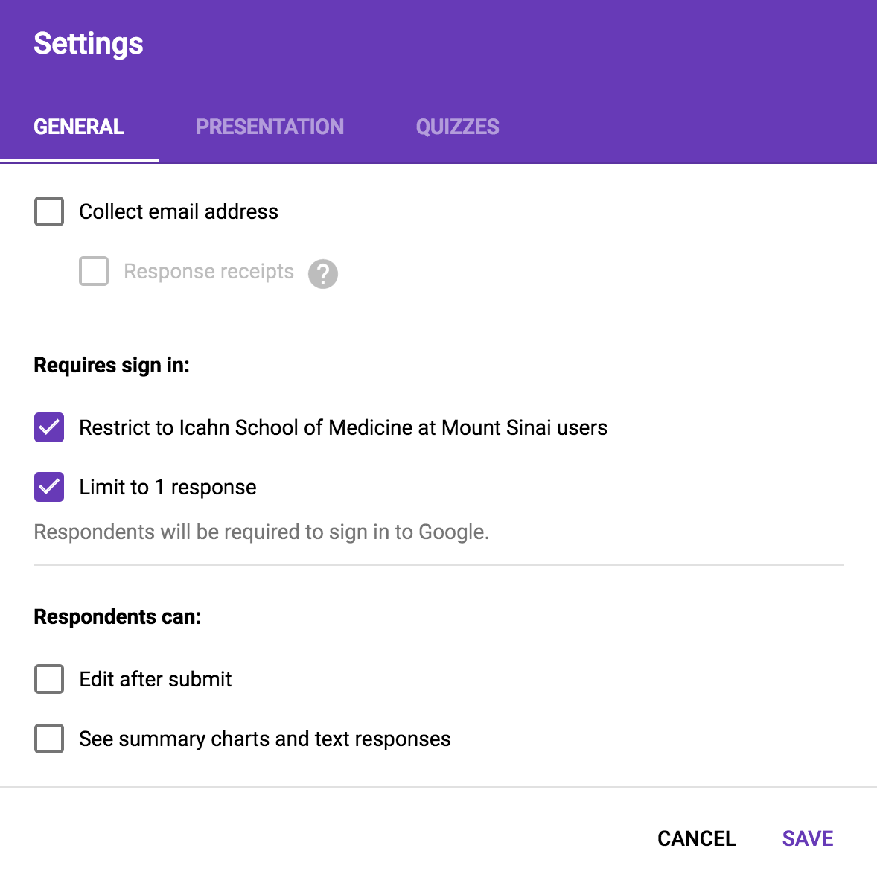
      - These surveys shall be constructed in accordance with section III.A.6 of the Constitution.
      - Elections shall last at least 72 hours.
    - Runoff elections will be held if required, pursuant to section III.A.6.e. of the Constitution.
      - An announcement of a runoff election will be made to the eligible voters via email no later than 12 hours after the election requiring a runoff has ended.
      - Runoff elections shall begin no later than 12 hours after the election requiring a runoff has ended, but no sooner than the announcement of the runoff election.
      - Runoff elections shall be conducted via Google Forms visible to ISMMS students only, using the settings described in section II.A.5.a of these Bylaws.
      - These surveys shall be constructed in accordance with section III.A.6 of the Constitution.
      - Runoff elections shall last exactly 36 hours.
  - Elections for the Steering Committee shall take place at the final meeting of the school year in accordance with section III.B. of the Constitution.
    - Elections shall take place in the following order: President, Vice-President, Treasurer, Secretary, and finally, any At-Large Positions as needed according to the Constitution.
    - Nominations for a given position shall be submitted in accordance with section III.B.1. of the Constitution prior to voting on that position but not before voting has completed and the results have been announced for the previous position as defined by the order in section II.B.1. of these Bylaws.
    - Candidates for positions on the Steering Committee shall be elected to office in accordance with section III.B.2. of the Constitution.
      - Each candidate shall be permitted to speak on his or her own behalf for a maximum of two minutes. The candidates shall speak in alphabetical order by last name.
      - Once all candidates have had the opportunity to speak, the candidates shall leave the room where the discussion is to be held.
      - The President of The Icahn School of Medicine at Mount Sinai Student Council shall lead the discussion regarding the candidates.
        - Any student, with the exception of the President of The Icahn School of Medicine at Mount Sinai Student Council, may speak regarding the merits of the candidates.
        - Any student speaking regarding the candidates may speak for a maximum of one minute.
        - Any student speaking regarding the candidates may speak for a maximum of two times per race.
        - The President is not permitted to speak regarding the candidates.
        - In the event that the President is one of the candidates in a race, the Vice-President shall act as the President for the purposes of the discussion for that race only.
        - In the event that both the President and the Vice- President are candidates in the same race, the most senior fourth year medical school officer shall act as President for the purposes of the discussion for that race only.
        - The President or acting President shall make every effort to alternate between viewpoints during the discussion when possible.
        - Once the discussion for a given race is complete, the candidates shall be invited back into the room.
      - Voting for Steering Committee representatives shall take place by secret ballot and in accordance with section III.B.2. of the Constitution.
        - The Steering Committee shall prepare numbered paper ballots for each race.
        - The number of ballots per race shall be equal to the number of eligible voting members of The Icahn School of Medicine at Mount Sinai Student Council.
        - The ballots shall be randomly distributed to the eligible voting members of The Icahn School of Medicine at Mount Sinai Student Council such that the ballots are anonymous.
        - All members of the steering committee, including those who are candidates in a race, shall verify the results of the voting.
        - Steering committee members are prohibited from discussing the number of votes submitted for a candidate in a race except to announce the final result.
      - Once all positions on the Steering Committee have been elected, the President shall ask if there are any challenges to the election results.
        - In the event that there is a challenge to the election results, the President shall follow the guidelines outlined in section III.B.3. of the Constitution.
        - In the event that there are no challenges, the President shall ask for a vote of certification, in accordance with section III.B.3. of the Constitution.
      - Once the vote of certification of the Steering Committee election results has passed, Steering Committee elections are complete.
    - The At-large position reserved for a first year medical school class officer shall be determined at the first meeting of the school year, following Fall Elections.
      - All first year officers shall be informed of the special subcommittees, including the Steering Committee, and the mechanism by which officers join special subcommittees, as described in sections I.A.9. and II.B.4. of these Bylaws, immediately upon being elected as officers.
      - Any first year officer who wishes to be a candidate for the first year At-large position shall announce himself or herself as a candidate at the first meeting following Fall Elections.
      - Election of the first year At-large position shall take place exactly as described in section II.B.3. of these Bylaws.
    - The Biomedical Inclusion Representatives shall be elected as described in section III.A of the Constitution. Upon their election as officers by their constituents, they shall become members of the Steering Committee without an election by the Student Council.
  - Voting shall follow guidelines that vary depending on the subject being voted upon and the people eligible to vote.
    - For all votes, regardless of topic, in which the entire student body or a portion thereof not restricted to the officers of The Icahn School of Medicine at Mount Sinai Student Council is eligible to vote:
      - All votes shall be conducted as Google Forms visible to ISMMS students only, using the settings described in section II.A.5.a of these Bylaws.
      - An announcement that a vote is to take place shall be sent via email to all students eligible to vote no later than 24 hours before the voting is to begin.
      - Surveys shall be available for no less than 48 hours.
    - Voting guidelines for votes in which only officers of The Icahn School of Medicine at Mount Sinai Student Council are eligible to vote shall vary depending on the subject of the vote.
      - For all votes that lead to the election or appointment of an officer or subcommittee representative, including elections of the Steering Committee, votes shall follow the guidelines outlined in section II.B.3.d. of these Bylaws.
      - For all votes that take place during a meeting, voting shall be done by a simple show of hands unless otherwise requested by an officer.
      - For all votes that take place between meetings:
        - All votes shall be conducted as Google Forms visible to ISMMS students only, using the settings described in section II.A.5.a of these Bylaws.
        - An announcement that a vote is to take place shall be sent via email to all officers no later than 24 hours before the voting is to begin.
        - Surveys shall be available for no less than 48 hours.
        - Results of such votes shall be announced at the next meeting following the vote.

- FINANCES
    - The budget is to be written by the Treasurer(s) of The Icahn School of Medicine at Mount Sinai Student Council in accordance with section IV.B. of the Constitution.

- MEETINGS
  - Meetings of The Icahn School of Medicine at Mount Sinai Student Council shall be announced to the entire student body by the Secretary via email no less than three days before the meeting is to take place.
  - The activities and attendance at all meetings shall be recorded by the Secretary as the Minutes.
    - Minutes from a given meeting shall be posted on the Student Council website by the Secretary no later than one week after the meeting.
  - The purpose of meetings is to inform the students of The Icahn School of Medicine at Mount Sinai Student Council as to the status of the school and to provide a public forum for the students to debate and officers to vote on motions.
    - All subcommittees, including special subcommittees, shall have the opportunity to present updates at General Body meetings. Subcommittees may request a specific time allotment at a meeting by contacting the Secretaries at least one day before the meeting. The President makes the final decision on the agenda for each meeting, as specified by section V part C of the Constitution.
    - Meetings shall be run in accordance with section V of the Constitution.

- RESOLUTIONS
    - The students of Icahn School of Medicine at Mount Sinai are committed to a policy against discrimination based on age, color, handicap or disability, ethnic or national origin, race, religion, gender, veteran status, or sexual orientation. We welcome employers who abide by this policy to use the Levinson Student Center for recruiting purposes. One employer - the United States Armed Forces - has recently requested access to the Student Center despite the Congressionally-mandated policy that openly gay men and women cannot not serve in the military. Because no employer deserves the special right to the Student Center without adhering to the same nondiscrimination policy followed by all other recruiting employers, we will not grant the military access to the Student Center. This decision by the Student Council comports with the recent decision of the U.S. Supreme Court 2. in Rumsfeld v. FAIR because the Levinson Center is student-operated property and military recruiters will still be allowed to use other available space throughout the medical school, therefore the Court's ruling does not apply. We students have chosen to exclude military recruiters from the Student Center despite our great respect for the men and women who serve in the Armed Forces. We look forward to the day Congress repeals the military's discriminatory policy and allows openly gay and lesbian Americans to serve the United States with honor. When that day comes, we students will enthusiastically welcome military recruiters to the Student Center. (Motion Passed on 2-20-07)

Revised 4/10/2012 by Nishant Goyal.

Comments and updates added March 2017 by Theodore Pak, based on votes recorded in meeting minutes and discussion/revisions by officers of Student Council. Edits were approved in whole by vote of the officers of Student Council on 4/12/2017.

Updated in April 2018 by James Blum to eliminate FMT (9/19/17), include an additional genetic counselor representative (11/8/17), a new at-large Steering position for the PhD program (11/8/17), a new at-large Steering position for the master’s programs (11/8/17), the new URiSM representative (2/14/18), and an additional CLR representative (3/14/18).

Updated in July 2018 by Nick Upright to organize and clarify the roles, responsibilities, and election procedures of PhD program officers within The Icahn School of Medicine at Mount Sinai Student Council.

Updated in April 2019 by Jordyn Feingold to add the second Vice President position.

